Date: 02/09/2017 Name:_____________
========Review========
P320: 10.32 (b)

(d)

10.37 (a)

======== 10.2 Factoring Quadratics a =1 =======
Cross method
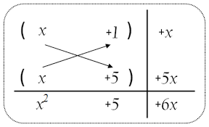
P293: 10.6

10.8(a)

(b)

(c)

(d)

(e)

10.9

10.10

======== 10.3 Factoring Quadratics a $≠$1 =======
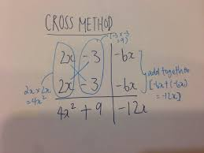
P298: 10.11

10.12 (use cross method to factor the expression)

10.14 (use cross method to factor the expression)

10.17

10.18

===============Homework===============
Read the summary and answer the following questions.
P298: 10.2.1(a)

(b)

(c)

10.2.2

10.2.3

10.2.4

P307: 10.3.1(a)

10.3.2

Expand
(x-x₁)(x-x₂)(x-x₃)
=

=

(x-a)(x-b)(x-c)
=

=

P320: 10.32 (c)

10.34(a)

(d)

10.37 (c)

(d)

10.42

10.49

10.51

10.55

10.57

